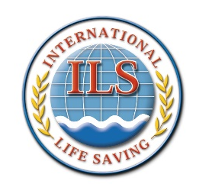

World Water Safety

INTERNATIONAL LIFE SAVING FEDERATION

Gemeenteplein 26 – 3010 Leuven - Belgium
Tel: +32/ 16 896060 - E-mail: ils.hq@telenet.be - Web: http://www.ilsf.org

Application Form to apply for funding from the LWC 2020 Developing Nations Fund

This form must be sent to j.martin@ilsf.org by 31st March 2020. Late applications will not be accepted.

Federation
Your Name
Your E-mail
Your Function

Tick the appropriate box
What |  | Yes | No
My Federation is in good standing with the ILS

My Federation accepts the terms and conditions of this generous offer from the Italian Federation
My Federation will enter at least one man into the LWC 2020 NTO

My Federation will enter at least one woman into the LWC 2020 NTO

For information only – my federation intends to enter additional competitors into the LWC 2020 NTO – enter the number of men and women your federation expects to enter |  | Men | Women
Date of application:

*If the federation chooses to have the accommodation and service package costs deducted from the funding, only the balance due will be paid

I confirm that the above information is correct.

………………………………………………………
Signature

Privacy and Data Protection
I understand and agree that the information I have provided is necessary for the legitimate interests of the International Life Saving Federation (ILS) and its management and administration. The collected information is subject to the ILS Privacy Policy available on the ILS website at https://www.ilsf.org/about/policies/ which I have read. I understand that the ILS will not share my personal data with other organisations for any other purpose than that for which the data was collected, including to verify eligibility, to communicate with and to inform about the activities of the organisation and in connection with the administration of its events and that the ILS Privacy Policy sets out my rights, including the right to withdraw my consent, in connection with the use of my personal data.

