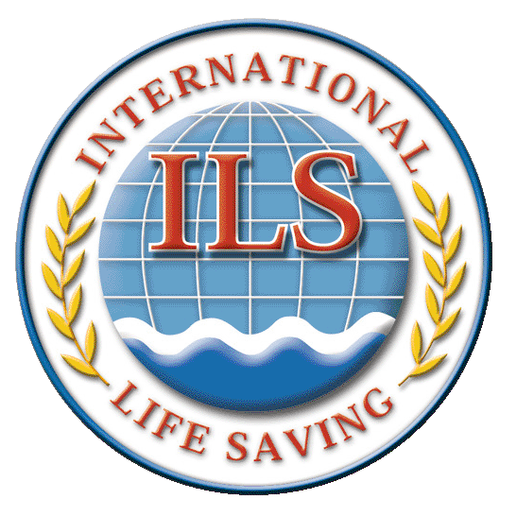
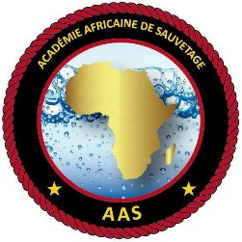

OFFICIAL INVITATION

- To all African Member Federations
of the International Lifesaving Federation (ILS)
- To the members of the Board of Directors of the
African Lifesaving Confederation
- To the members of the Board of Directors of
the African Lifesaving Academy

Rabat, 5 November 2019

Dear friends,

As you know, the International Lifesaving Federation (ILS) is the global authority for drowning prevention, water rescue and lifesaving sport. ILS leads, supports and collaborates with national and international organisations engaged in drowning prevention, water safety and rescue, first aid and lifesaving sport. More than 38 million people in more than 168 countries (as of 2019) are involved worldwide in the field of drowning prevention, rescue and lifesaving. ILS is recognised by the International Olympic Committee, the World Health Organisation of the United Nations and many other organisations.

The Royal Moroccan Lifesaving Federation (RMLF), with the cooperation with the International Lifesaving Federation (ILS) and the African Lifesaving Academy (ALA) organises two major courses in February 2020:

- A course to become ILS International Instructor
- A recertification course for ILS International Instructor

We give you below the information of both courses. Please read all the information provided.

Dr. Mohamed Ali Gharbal Dr. Mohamed Saleh MD
President RMLF and ALA President ILS-Africa

Dr. Harald Vervaecke PhD
ILS Secretary General

USEFUL INFORMATION

- PROGRAMME

Course for ILS International Instructors
Dates | Programme
Sunday 16/02/2020 | Arrival of students and registration
Monday 17/02/2020 | 09.00 - 17.30 - Course: day 1
Tuesday 18/02/2020 | 09.00 - 17.30 - Course: Day 2
Wednesday 19/02/2020 | 09.00 - 17.30 - Course: day 3
Thursday 20/02/2020 | 09.00 - 17.30 - Course: day 4
Friday 21/02/2020 | 09.00 - 17.30 - Course: day 5
Saturday 22/02/2020 | 09.00 - 16.00 - Examination  19.00 - 21.00 - Closing dinner and proclamation
Sunday 23/02/2020 | Departures

Re-certification of ILS International Instructors
Dated | Program
Sunday 23/02/2020 | Arrival of students and registration
Monday 24/02/2020 | 09.00 - 17.30 - Course: day 1  19.00 - 21.00 - Closing dinner and proclamation
Tuesday 25/02/2020 | 09.00 - 1 6.00 - Course: day 2  16.00 - 16.30: distribution of certificates  After 16.30: departures
Wednesday 26/02/2020 | Departures

- COURSE 1. ILS International Instructor COURSE

The aim of the course is to train ILS International Pool Lifeguard and Beach/Surf Lifeguard Instructors. Students must already be Pool Lifeguard or Beach Lifeguard before entering the course. The course is spread over five long days of classes and one day of examination. Upon completion of the certification, Pool Lifeguard Instructors or Beach/Surf Lifeguard Instructors will be able to teach candidates who wish to become an International Pool Lifeguard and / or International Beach/Surf Lifeguard in their home country.

- COURSE 2. Re-certification of ILS International Instructors

The purpose of the course is to recertify people who are already Pool Lifeguard Instructor or Beach/Surf Lifeguard Instructor for a period of three years (2020 to late 2022). The course is spread over two days of classes.

- LOCATION

Both courses will be held in Agadir, Morocco.

- Conditions of admission

To be admitted to Course 1. ILS International Instructor Course, students must present a pool lifeguard certificate or a beach/surf lifeguard certificate, present a medical fitness certificate and be at least 21 years old at the beginning of the course.

To be admitted to Course 2. ILS International Instructor rectification, students must present an International Instructor Certificate from the ILS.

- Language of the course

The course will be in three languages: French, English or Arabic. The candidate must master one of these three languages ​​perfectly.

- FINANCIAL ASPECTS

Visa
Each candidate or the applicant's Federation covers visa fees. The RMLF will assist in sending individual invitation letters to embassies. Students are encouraged to not wait in obtaining a visa since that takes some time.

Air Ticket
Each candidate or the Federation of the candidate covers the cost of air tickets from his country to the airport of Agadir.

Transport from Agadir airport to the hotel and back
The RMLF covers the cost of transportation from Agadir Airport to the hotel and from the hotel to Agadir Airport.

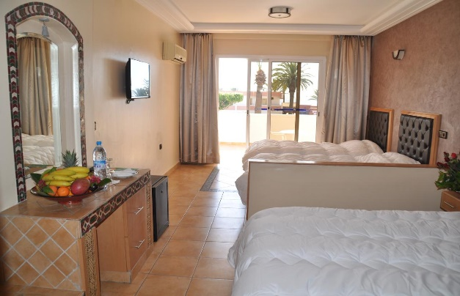
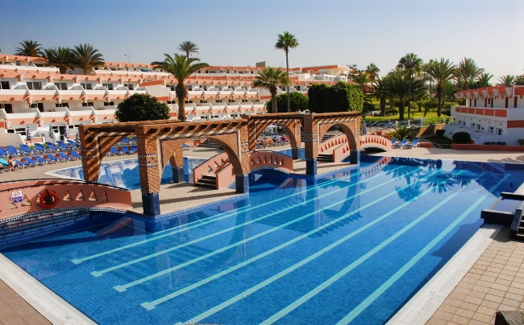
Accommodation

Students will stay at the Al Moggar Hotel in Agadir. Each candidate or the candidate's Federation must cover the hotel costs of 40 Euro per person and per day. The 40 Euro per person and per day covers accommodation in large rooms with two or three people per room, breakfast, lunch and dinner: thus the 40 Euro per person and per day covers accommodation and three meals a day.

Admission fee
The ALA covers the admission fee which normally amounts to 140 Euro.

Other expenses
- The RMLF covers the costs of renting the premises, the swimming pool, the provision of equipment, the cost of insurance. All these costs are normally 50 Euro.
- The ILS covers the provision of instructors, the cost of photocopying the manual in one language, fees for certificates, cards, pins and badges, polo and cap costs. All these fees are normally 120 Euro per student.

- REGISTRATION AND ACCREDITATION

Each student must be registered and receive accreditation. Students must pay the full amount of accommodation and food at the time of registration. This amount is 40 Euro per person and per day. Without this payment, the candidate will not be admitted to the course and will not receive accommodation.

- Deadline for sending the APPLICATION file

Applications must be received by RMLF headquarters by January 15, 2020. To register, use the registration form provided in this certificate.

- Limits of students per course

A maximum of 75 students will be allowed per course for the Instructor course. No limits apply for the re-certification course.

- INSTRUCTORS

Course Directors are:
- Dr. Harald Vervaecke PhD, Secretary General of the International Rescue Federation (ILS).
- Dr. Mohamed Ali Gharbal PhD, President of the FRMS and the Academy.

The Deputy Director is :
- Mr Abdelkader Chekroun, Vice-President of the Academy.

The co-Instructors are:
- Mr Khalil Loksairy.
- Mr Samy Smouni.
- Mr Adil Billi.

- YOUR ADVANTAGES

The following costs are covered for students: local transportation costs, admission fees, space and pool rental fees, equipment availability, insurance fees, copy costs of the manual, the certificate fee, cards, pins and badges, the cost of polo and cap. All this is worth more than 310 Euro per student: a gift from RMLF, ALA and the ILS.

INTERNATIONAL LIFE SAVING FEDERATION - AFRICA BRANCH

COURSES IN 2020 IN AGADIR - MOROCCO

REGISTRATION FORM

Instructor Course | YES: | NO:
Recertification | YES: | NO:

Name
(Like in passport)
Forename
(Like in passport)
Gender
Date of Birth
(DD-MM-YYYY)
Place of Birth (City)
Nationality
Tel. Mobile
E-Mail
Passport number
Which Lifeguard qualification do you have?

ARRIVAL DATA AT AGADIR AIRPORT
Arrival Date in Agadir Airport
Arrival Time in Agadir Airport
Flight Number

DEPARTURE DATA FROM AGADIR AIRPORT
Departure date from Agadir
Departure time from Agadir
Flight Number

By signing this document, the undersigned declares that he/she is medically fit to take the course.

PLEASE MAIL ALSO PICTURE OF YOU IN JPG.

Date: Signature:

